Cyclic Sort

1) Definition
Cyclic Sort is a pattern used when:
- The array contains numbers in a fixed range (usually 1 to N or 0 to N)
- Goal is to place every number at its correct index
  - For range 1 to N → correct index = value − 1
  - For range 0 to N → correct index = value
Instead of fully sorting, we repeatedly swap elements into their correct positions until every valid number is placed correctly.

2) When to Use (Key Conditions)
Use Cyclic Sort when the problem mentions:
- Numbers from 1…N or 0…N
- Missing numbers
- Duplicate numbers
- Corrupted or misplaced elements
- Finding the smallest missing positive
- Constant space requirement
- Linear time expectation

3) Advantages
- Time Complexity: O(N) (very fast)
- Space Complexity: O(1) (in place)
- No need for extra data structures
- Avoids full sorting
- Ideal for interview trick questions

4) Benefits
- Extremely efficient under special constraints
- Elegant and compact code
- Works for multiple problem types:
  - Missing numbers
  - Duplicates
  - Misplacements
  - First missing positive
- Reduces unnecessary comparisons

5) Pattern Recognition Clues
Look for phrases like:
- “Numbers from 1 to N”
- “Find missing number”
- “Find duplicate”
- “Find corrupted pair”
- “Place elements in correct index”
- “Constant extra space”

6) Core Algorithm Steps
Step 1: Start from index i = 0
Step 2: For each element:
- Compute correct index:
correct = nums[i] - 1 (for 1…N)
- If element is not at correct position AND is within range
→ swap with element at correct index
- Else
→ move to next index
Step 3: After placement loop, scan array to detect anomalies
(missing, duplicate, misplaced)

7) Generic Pseudocode
int i = 0;
while (i < n) {
int correct = nums[i] - 1;
if (nums[i] >= 1 && nums[i] <= n && nums[i] != nums[correct]) {
swap(nums, i, correct);
} else {
i++;
}
}

8) What You Can Detect After Placement
After cyclic positioning:
Observation | Meaning
Index i ≠ nums[i] − 1 | Missing number or duplicate
Correct placement everywhere | Array already valid
Multiple mismatches | Multiple missing/duplicates
Out-of-range values | Ignore during swaps

9) Summary
For arrays with values in a fixed range:
- Place each number at its index
- Then scan for mismatches
- Mismatches reveal the answer
Think of it as a range-based positioning technique, not a comparison sort.

Important LeetCode Problems (Easy → Hard)
🟢 Easy
- 268 — Missing Number
- 645 — Set Mismatch
- 448 — Find All Numbers Disappeared in an Array

🟡 Medium
- 287 — Find the Duplicate Number
- 442 — Find All Duplicates in an Array
- 41 — First Missing Positive ⭐ (very important)

🔴 Hard / Trick Variants
- Variants combining:
  - Missing + duplicate together
  - Out-of-range values
  - Multiple missing numbers
  - Unsorted corrupted arrays

Cyclic Sort — Visualization
Example: nums = [3, 1, 5, 4, 2] (Range 1…N)
Goal: Place each number at index = value − 1
Correct final form: [1, 2, 3, 4, 5]

Initial Array
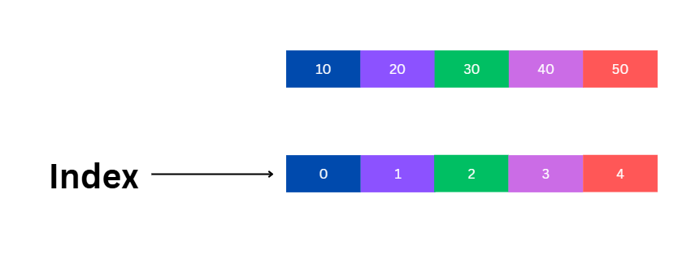

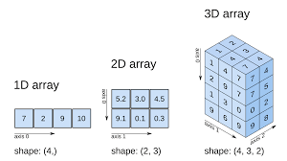
4
Index → 0 1 2 3 4
Value → 3 1 5 4 2

Step 1 — Place 3 at Correct Position
3 should be at index 2
Swap nums[0] ↔ nums[2]

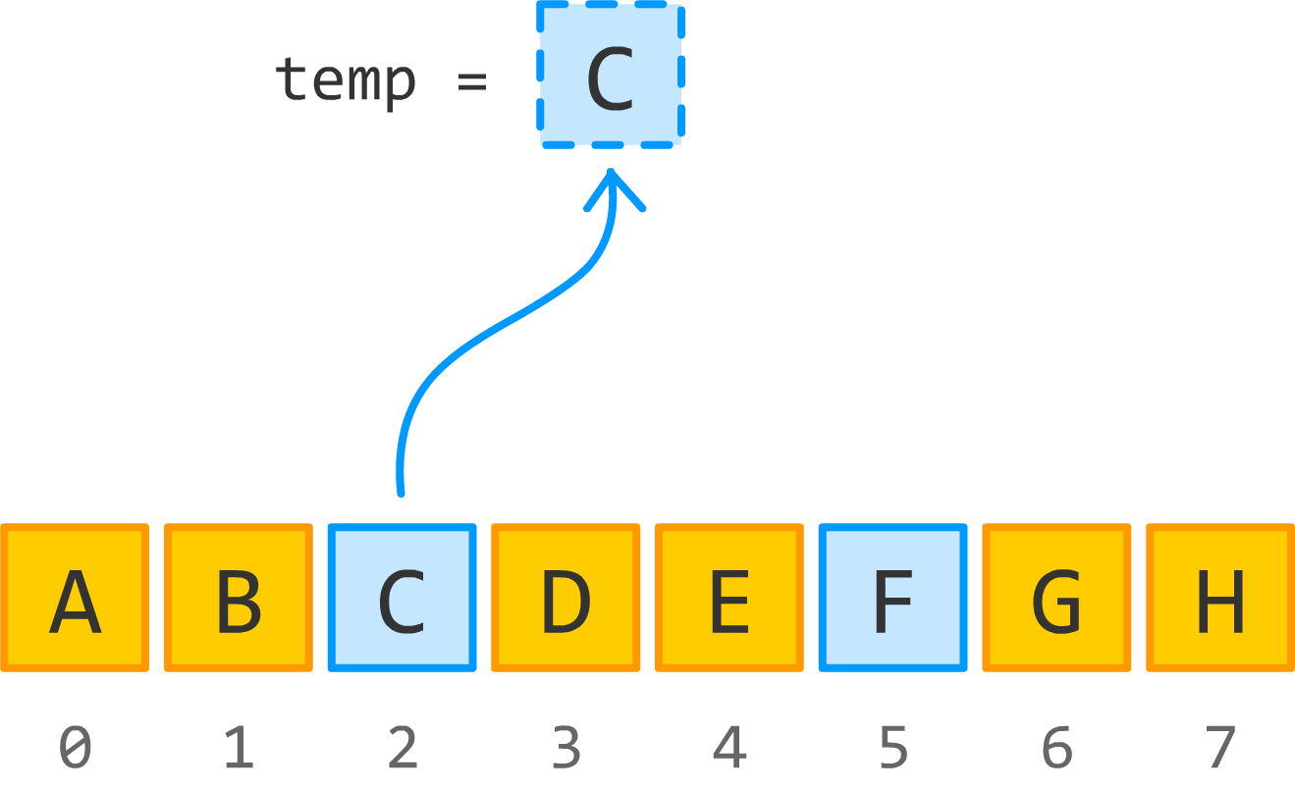

4
Array → [5, 1, 3, 4, 2]

Step 2 — Place 5 at Correct Position
5 should be at index 4
Swap nums[0] ↔ nums[4]

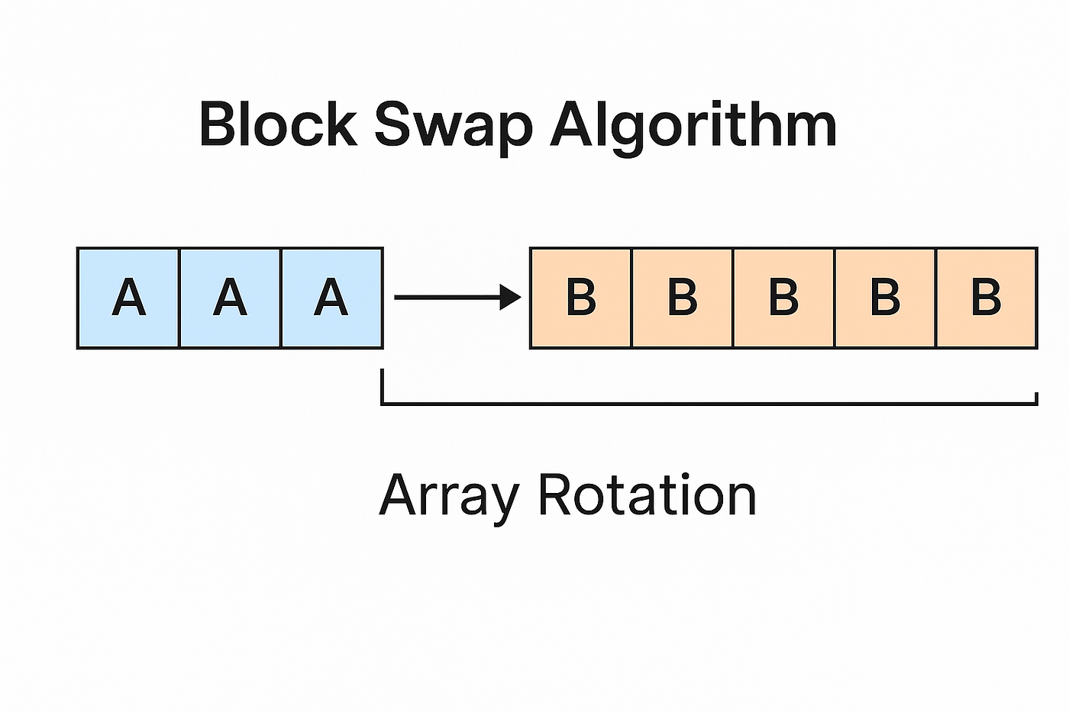
4
Array → [2, 1, 3, 4, 5]

Step 3 — Place 2 at Correct Position
2 should be at index 1
Swap nums[0] ↔ nums[1]

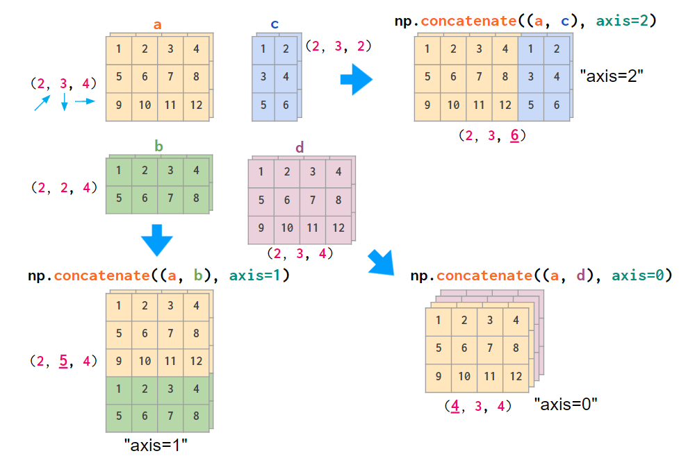
4
Array → [1, 2, 3, 4, 5]

Step 4 — Check Remaining Indices
Now every number is at its correct index:
Index | Value | Correct?
0 | 1 | ✔
1 | 2 | ✔
2 | 3 | ✔
3 | 4 | ✔
4 | 5 | ✔

Final Result
Cyclic Sort finishes in linear time because each swap places at least one element in its final position.

Mental Model (Important)
👉 Each number “travels” directly to its home index
👉 No comparisons like normal sorting
👉 Only swaps based on value

